For patients
The organizations involved in the current pilot study are urgently working to develop safe and effective treatments for age-related macular degeneration. This study is only the first step of many that will be needed to determine whether this transplantation of autologous iPSC-derived RPE cell sheets will be appropriate for use in the treatment of this disease. Due to the preliminary nature and small size of the study, the requirement for intensive long-term monitoring, the possible need for rapid access to emergency medical treatment, and the importance of clear communications with research and medical staff, including documentation required for the study, enrollment will be limited in principle to residents of Japan. The results of the study will be published as soon as they are available, and if they support the preliminary safety of this approach, may lead additional larger-scale research and development efforts in Japan and other countries.

About AMD

Retinal pigment epithelium
The macula is the central region of the retina and plays important roles in light-sensing and visual acuity. The retina is made of up a sensory retina layer that contains a type of neurons known as photoreceptors that convert light signals into neural activity and a supporting layer of non-neural cells called retinal pigment epithelium (RPE). The RPE acts as a barrier that separates the eye from the rest of the body, absorbs cellular waste materials, and also serves as a source of molecules called trophic factors that are needed for the survival and function of other nearby cells. Damage to the RPE can thus also affect the function of the sensory retina.

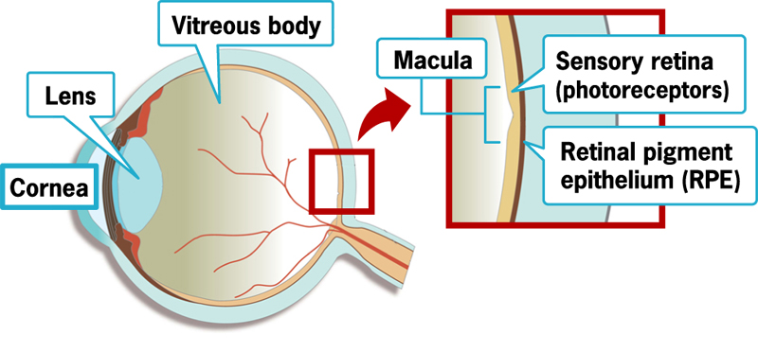

Age-related macular degeneration
In age-related macular degeneration (AMD), the function of the macula deteriorates with age, which can be due to a number of causes. In the neovascular or exudative form of AMD (often called ‘wet-type AMD’), abnormal growth of new blood vessels occurs in the region immediately next to the eye (a process known as choroidal neovascularization). These new blood vessels may leak serum or blood and invade the overlying tissue, causing damage to the RPE and sensory retina.
The early symptoms of AMD include loss of acuity and contrast sensitivity in the center of the visual field, object distortion, blurring, and dimness of vision. In some cases, the onset of symptoms is rapid. As AMD increases in severity, it can lead to retinal detachment or hemorrhage, which can cause loss of vision in other parts of the eye as well.

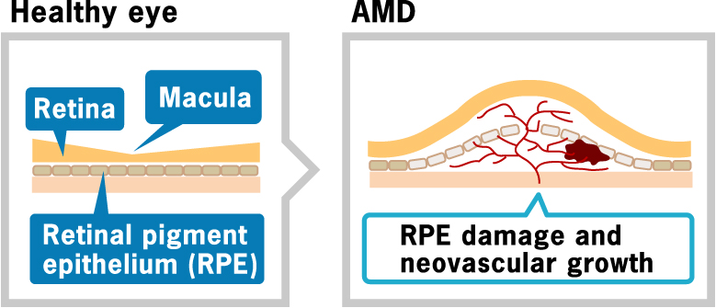

Causes of AMD
The precise cause of AMD remains unknown, but aging, inflammation, and genetic factors are believed to play roles in weakening of the RPE. A second form of the disease, atrophic (or dry-type) AMD, is prevalent in people of European descent, while the wet-type is more common in Japan and other parts of East Asia. In Japan, around 1% of all people aged 50 and older suffer from some form of AMD.

Current treatments
Most current forms of treatment for wet-type AMD focus on stopping the abnormal blood vessel growth known as choroidal neovascularization, with the goal of preventing further progression of the disease. If neovascularization is absent in the fovea (the center of the macula), a laser can be used to ablate the blood vessels, while in cases of foveal neovascularization, agents that inhibit the activity of VEGF, a molecule that promotes the formation of blood vessels, have been approved for use. However, such treatments only prevent the progression of the disease, and cannot repair tissue damage that has already occurred to the RPE or sensory retina. Thus, therapies that both halt the growth of new blood vessels and reconstruct damaged tissue are needed to fully treat the effects of this disease.

About clinical research
Testing for safety and efficacy is required before any new medical intervention can enter routine use. Such clinical research takes various forms that differ in the number of human research subjects and features of the study design. In Japanese law, two main types of clinical experiments are recognized: registered clinical trials, which are used to test medical products prior to market authorization, and general clinical research, which includes smaller-scale studies, such as the pilot study described in this website, and evaluations of some medical procedures, such as surgical techniques.
The research plan introduced in this website is for an open-label study of the transplantation of autologous induced pluripotent stem cell (iPSC)-derived retinal pigment epithelium (RPE) cell sheets in patients with exudative age-related macular degeneration (AMD). This is a very early-stage form of clinical research, and is intended to assess the safety of this intervention; it is not expected to yield significant improvements in visual acuity or other symptoms in the patients who participate in the study.

Important points
1) The current study is designed to evaluate this intervention only in patients with the exudative (wet-type) form of age-related macular degeneration.
2) The primary outcome to be assessed in this study is the safety of the intervention. If it is found to be acceptably safe, future studies will evaluate its efficacy. Patients who participate in this pilot study are not expected to experience dramatic improvements in their symptoms.
3) Enrolment in the study is limited to six subjects, as the safety of the intervention has not been established.
4) This pilot study is a very early stage of clinical research into the use of an iPSC-based intervention. Even in the event that this study suggests the intervention is acceptably safe to proceed to subsequent stages, a great deal of further research, including full-scale clinical trials, will be needed to more thoroughly evaluate the safety and efficacy of this approach.

Generation and transplantation of RPE cell sheets
In the first stage of the study, a 4 mm biopsy of tissue will be collected from the skin of each subject’s upper arm and cultured in a cell processing center. The skin cells will then be used to generate induced pluripotent stem cells (iPSCs). The autologous iPSCs will next be differentiated in culture into monolayer ‘sheets’ of retinal pigment epithelium (RPE) suitable for transplantation. The entire process, including regular assessments of safety and quality, will require approximately 10 months for each patient.

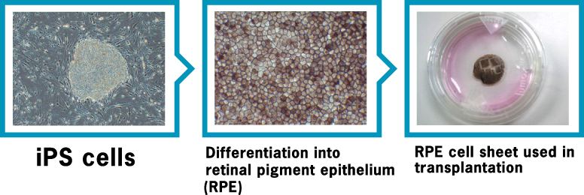

Transplantation
Once complete, the RPE cell sheets will be transplanted into the affected site in a single eye, from which the neovascular tissue has first been removed. Subjects will be monitored and followed up for four years following transplantation.
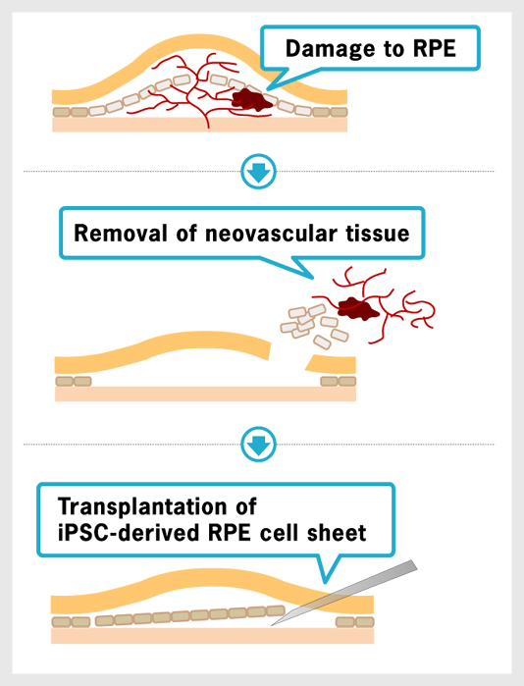

Potential risks and benefits
The primary goal of this pilot study is to evaluate the safety of the transplantation of autologous induced pluripotent stem cell (iPSC)-derived retinal pigment epithelium (RPE) cell sheets in patients with exudative age-related macular degeneration (AMD). Patients who participate in this study are not expected to experience dramatic improvements in visual acuity or other symptoms. In the event that the intervention is found to be acceptably safe in this small group of patients, much additional research will be needed to evaluate its safety and efficacy in larger numbers of patients.

Potential risks
This is a first-in-human study using RPE cells differentiated from a pluripotent stem cell source. While intensive preclinical research in cultured cells and animal models has been conducted, it is impossible to rule out the risk of tumor formation triggered by the transplanted cells. The harvesting of tissue from the arm to be used for generation of iPSCs is an invasive procedure and will be conducted under anesthesia, both of which are associated with some risk, and the transplantation procedure is associated with risks including bleeding, infection, retinal detachment, any of which can lead to loss of visual function. The physicians conducting the study will monitor closely for any such adverse events, and take all appropriate measures should an adverse event occur.

Timeline
After obtaining informed consent, volunteers will be screened for eligibility to participate in the study following a number of predefined inclusion and exclusion criteria – those selected will be enrolled in the ‘primary registration’ for the study. After primary enrollment, skin samples will be harvested from each patient and used to generate autologous iPSC-derived RPE cell sheets, a process that will take approximately 10 months.
After safety and quality testing, the RPE cell sheet will be prepared for transplantation. The terms of the original informed consent document will be reconfirmed with each subject, and providing the subject’s consent remains unchanged, he or she will be enrolled in the ‘secondary registration’ prior to transplantation. All patients will be intensively monitored for one year, with additional follow-up for three years following transplantation of the RPE cell sheet.

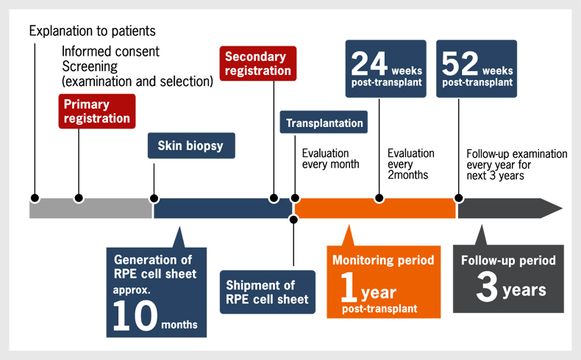

Post-transplant monitoring
All subjects will be monitored intensively for the first year following the transplantation of the RPE cell sheet, with monthly evaluations for the first 6 months and bimonthly evaluations for the next 6 months. These evaluations will include tests of visual function, intraocular pressure, and medical imaging. Data from these examinations will be compiled and analyzed to evaluate the safety of the intervention and any effects on visual function. During the 3-year follow-up period, subjects will have annual eye examinations. Comprehensive cancer screening will be conducted at the harvesting of the skin biopsy, prior to the transplantation of the RPE cell sheet, at one year post-transplant, and at the end of the follow-up period (4 years post-transplant). Following this 4-year post-transplant monitoring and follow-up period, additional long-term observation of the study subjects will be periodically conducted.

Partner organizations
This pilot study is a joint clinical research project coordinated and conducted by RIKEN, the IBRI (Institute for Biomedical Research and Innovation) Hospital, and the Kobe City Medical Center General Hospital. The IBRI Hospital will harvest skin biopsies, transplant RPE cell sheets, and conduct pre- and post-transplant monitoring of subjects. RIKEN will generate autologous iPSCs from the subjects’ skin cells and differentiate the iPSCs into RPE cell sheets. Kobe City Medical Center General Hospital will conduct some of the examinations during the monitoring period, support the screening process and, if necessary, provide emergency medical services.

